Objective Questions

Q1. What is the distribution of account balances across different regions?

select
g.GeographyLocation,
round(sum(b.Balance)) as total_amount,
round((sum(b.Balance) * 100/ (select sum(Balance) from bank_churn))) as balance_percentage
from customerinfo c
join geography g on c.GeographyID = g.GeographyID
join bank_churn b on c.CustomerId = b.CustomerId
group by g.GeographyID
order by total_amount;

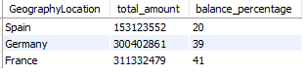

Q2. Identify the top 5 customers with the highest Estimated Salary in the last quarter of the year. (SQL)

select
*
from customerinfo c
where quarter(Bank_DOJ) = 4
order by EstimatedSalary desc
limit 5;

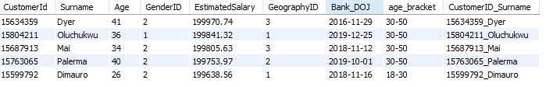

Q3. Calculate the average number of products used by customers who have a credit card. (SQL)

select
round(avg(b.NumOfProducts)) as avg_product
from bank_churn b
where b.HasCrCard = 1;

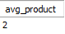

Q4. Determine the churn rate by gender for the most recent year in the dataset.

select
c.GenderID as gender_ID,
g.GenderCategory as gender_category,
count(case when b.Exited = 1 then 1 end) as exit_cus,
count(*) as total_Cus,
round(count(case when b.Exited = 1 then 1 end)/ count(b.CustomerId)) as churn_rate
from bank_churn b
join customerinfo c on b.CustomerId = c.CustomerId
join gender g on c.GenderID = g.GenderID
where b.Exited = 1 and year(c.Bank_DOJ) = 2019
group by gender_ID, gender_category;

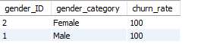

Q5. Compare the average credit score of customers who have exited and those who remain. (SQL)

select
e.ExitCategory,
round(avg(b.CreditScore)) as Avg_Creditscore
from bank_churn b
join exitcustomer e on e.ExitID = b.Exited
group by e.ExitCategory;

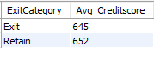

Q6. Which gender has a higher average estimated salary, and how does it relate to the number of active accounts? (SQL)

select
g.GenderCategory as customer_gender,
round(avg(EstimatedSalary)) as avg_estimated_salary,
count(c.CustomerId) as no_of_customer
from customerinfo c
join bank_churn b on c.CustomerId = b.CustomerId
join gender g on c.GenderID = g.GenderID
where b.IsActiveMember = 1
group by g.GenderCategory;

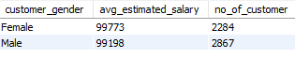

Q7. Segment the customers based on their credit score and identify the segment with the highest exit rate. (SQL)

WITH creditSegment AS (
SELECT
*,
CASE
WHEN CreditScore >= 781 THEN 'Excellent'
WHEN CreditScore BETWEEN 701 AND 780 THEN 'Very Good'
WHEN CreditScore BETWEEN 611 AND 700 THEN 'Good'
WHEN CreditScore BETWEEN 510 AND 610 THEN 'Fair'
ELSE 'Poor'
END AS CreditScoreSegment
FROM bank_churn
),
grouped_segment AS(
SELECT
CreditScoreSegment,
COUNT(CASE WHEN Exited = 1 THEN 1 END ) * 100 / COUNT(*) AS exit_customer_rate
FROM creditSegment
GROUP BY CreditScoreSegment
)

SELECT
CreditScoreSegment,
ROUND(exit_customer_rate,2) AS Max_Exit_Rate
FROM grouped_segment
ORDER BY exit_customer_rate DESC
LIMIT 1;

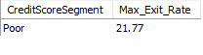

Q8. Find out which geographic region has the highest number of active customers with a tenure greater than 5 years. (SQL)

select
GeographyLocation,
COUNT(b.CustomerId) AS total_active_customer
from bank_churn b
join customerinfo c on b.CustomerId = c.CustomerId
join geography g on c.GeographyID = g.GeographyID
where IsActiveMember = 1 and Tenure > 5
group by GeographyLocation
order by total_active_customer desc
limit 1;

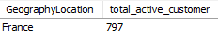

Q9. What is the impact of having a credit card on customer churn, based on the available data?

SELECT
c.Category,
COUNT(*) AS total_customer,
COUNT(CASE WHEN b.Exited = 1 THEN 1 END) AS total_exit_customer,
COUNT(CASE WHEN b.Exited = 1 THEN 1 END) * 100 / COUNT(*) AS churn_rate
FROM bank_churn b
JOIN creditcard c
ON b.HasCrCard = c.CreditID
GROUP BY c.Category;

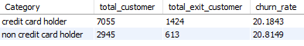

Q10. For customers who have exited, what is the most common number of products they have used?

SELECT
NumOfProducts,
COUNT(*) as no_of_product
FROM bank_churn
WHERE Exited = 1
GROUP BY NumOfProducts
ORDER BY no_of_product desc
LIMIT 1;

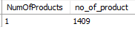

Q11. Examine the trend of customers joining over time and identify any seasonal patterns (yearly or monthly). Prepare the data through SQL and then visualize it.

select
date_format(Bank_DOJ, "%Y" ) as joining_year,
date_format(Bank_DOJ,"%m") as joining_month,
count(*) as total_customer
from customerinfo
group by joining_year, joining_month
order by joining_year;

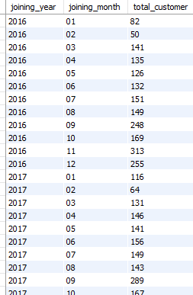

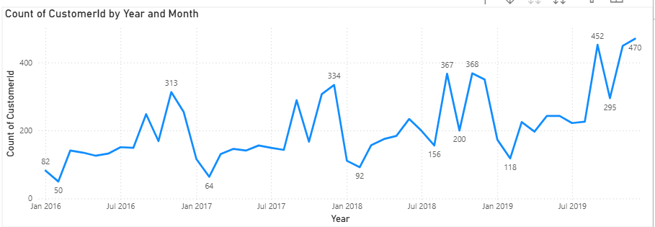

Q12. Analyze the relationship between the number of products and the account balance for customers who have exited.
The chart tells about the distribution of the average balance of exited customers over number of products used.
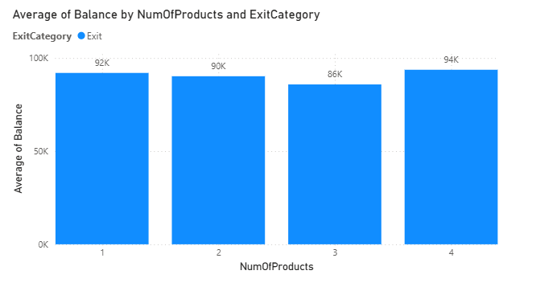
The average balance of exited customers is almost same, where customers with 4 products used are highest in average balance and with 3 products are least.

Q.13 Identify any potential outliers in terms of balance among customers who have remained with the bank.

We used a scatter chart in Power BI to spot unusual balance patterns among customers who have stayed with the bank. Looked for points that stand out either much higher or lower than most others since these could be potential outliers. Once we identify these unusual balances, took a closer look to see if they make sense. They could be due to data entry mistakes, fraudulent activity, or just unique customer behaviour. Understanding why these outliers exist can help us to decide if any action is needed.
By using a scatter chart this way, we can discover hidden patterns in customer balances and gain valuable insights into their financial behaviours.

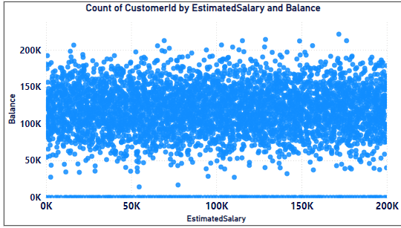

Q.14 How many different tables are given in the dataset, out of these tables which table only consists of categorical variables?
The dataset has seven different tables they are, Active Customer, Bank Churn, Credit Card, Customer Info, Exit Customer, Gender, Geography.
Categorical columns in a dataset contain discrete values that represent categories or groups rather than numerical measurements.
These columns are used for classification and grouping rather than mathematical operations.
Tables and their Categorical Variables:
- Customer Info: GeographyID, GenderIDare categorical variables.
- Bank_Churn: HasCrCard, isActiveMember and Exited are categorical variables.
- Exit Customer: ExitID and ExitCategory are categorical variables.
- Gender: GenderID and GenderCategory are categorical variables.
- Geography: GeographyID and GeographyCategory are categorical variables
- Active Customer: ActiveID and Active Category are categorical variables
- Credit Card: CreditID and CreditCategory are categorical variables.
Among the 7 tables, there are 5 tables which consists of only categorical variables. They are Exit Customer, Gender, Geography, Active Customer and Credit Card.
Q15. Using SQL, write a query to find out the gender-wise average income of males and females in each geography id. Also, rank the gender according to the average value. (SQL)

select
GeographyLocation,
GenderCategory,
round(avg(EstimatedSalary )) as avg_salary,
rank() over(partition by GeographyLocation order by avg(EstimatedSalary) desc) as rnk
from customerinfo c
join geography geo on geo.GeographyID = c.GeographyID
join gender g on c.GenderID = g.GenderID
group by GeographyLocation, GenderCategory ;

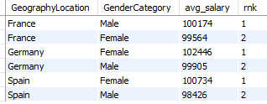

Q16. Using SQL, write a query to find out the average tenure of the people who have exited in each age bracket (18-30, 30-50, 50+).

UPDATE customerinfo
SET age_bracket =
CASE
WHEN Age > 50 THEN '50+'
WHEN Age BETWEEN 31 AND 50 THEN '30-50'
ELSE '18-30'
END
WHERE customerId IS NOT NULL;

select
age_bracket,
round(avg(b.Tenure),2) as avg_tenure
from customerinfo c
join bank_churn b on c.CustomerId = b.CustomerId
where b.Exited = 1
group by age_bracket;

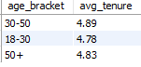

Q17. Is there any direct correlation between salary and the balance of the customers? And is it different for people who have exited or not?
Below is the scatter plot for Salary and Balance.
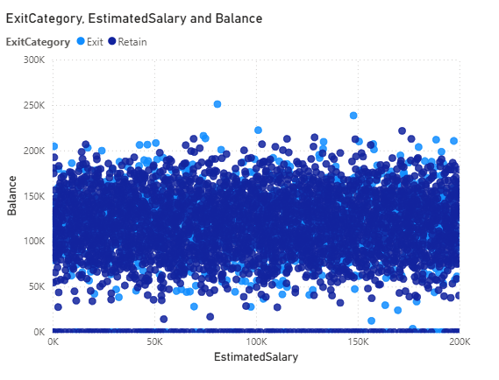

The above scatter plot does not show a strong or clear relationship between these variables.
The data points are evenly distributed across different salary and balance ranges, indicating no consistent pattern where higher or lower salaries correspond to higher or lower balances.
Additionally, the two Exited categories (represented by different shades) are dispersed throughout the chart, suggesting that customer churn is not directly influenced by salary or balance based on this visual representation.

Q18. Is there any correlation between the salary and the Credit score of customers?

Scatter plot for Salary and Credit Score.

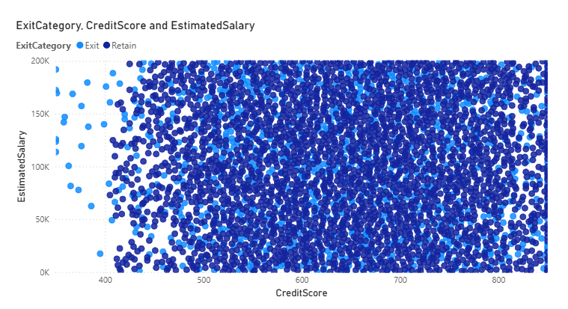

There is no strong or clear correlation between Credit Score and Estimated Salary. The data points are widely and evenly distributed across all ranges, indicating no evident linear relationship. Additionally, the Exited status (0 or 1) appears uniformly spread across different credit scores and salary levels, suggesting that neither factor alone is a strong predictor of customer churn.
While some variation exists, the graph does not visually reveal any distinct pattern or correlation between these variables and exit behavior.
Q19. Rank each bucket of credit score as per the number of customers who have churned the bank.

select
case when creditscore <= 579 then "Poor"
when creditscore between 580 and 669 then "Fair"
when creditscore between 670 and 739 then "Good"
when creditscore between 740 and 799 then "Very Good"
when creditscore>=800 then "Excellent"
end as `credit score bucket`,
count(case when exited =1 then customerid end) as exit_rate,
dense_rank() over(order by count(case when exited =1 then customerid end) desc) as `bucket rank`
from
bank_churn
group by
`credit score bucket`;

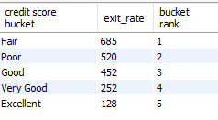

Q20. According to the age buckets find the number of customers who have a credit card. Also retrieve those buckets that have lesser than average number of credit cards per bucket.

select
age_bracket,
count(b.customerId) as total_customer_has_CrCard
from bank_churn b
join customerinfo c on c.CustomerId = b.CustomerId
where HasCrCard = 1
group by age_bracket
order by total_customer_has_CrCard asc;

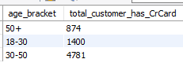

Q21. Rank the Locations as per the number of people who have churned the bank and average balance of the customers.

with grouped_location_data as (
select
g.GeographyLocation as location,
round(count(case when Exited = 1 then 1 end ) * 100 / count(c.CustomerId),2) as churn_rate,
round(avg(Balance),2) as avg_balance
from bank_churn b
join customerinfo c on b.CustomerId = c.CustomerId
join geography g on g.GeographyID = c.GeographyID
group by location
)

select
*,
rank() over(order by churn_rate desc, avg_balance asc) as location_rank
from grouped_location_data;

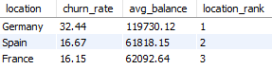

Q22. As we can see that the “CustomerInfo” table has the CustomerID and Surname, now if we have to join it with a table where the primary key is also a combination of CustomerID and Surname, come up with a column where the format is “CustomerID_Surname”.

alter table customerinfo add CustomerID_Surname varchar(50);

update customerinfo
set CustomerID_Surname = concat (customerId, "_", Surname)
where CustomerId is not null;

Q23. Without using “Join”, can we get the “ExitCategory” from ExitCustomers table to Bank_Churn table? If yes do this using SQL.

select
b.*,
(select ExitCategory from exitcustomer e where e.ExitID = b.Exited) as ExitCategory
from bank_churn b;

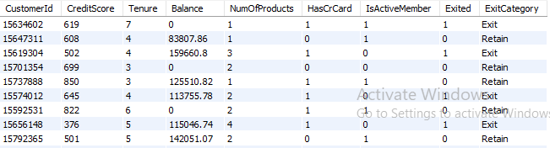

Q24. Were there any missing values in the data, using which tool did you replace them and what are the ways to handle them?
There are multiple ways to handle missing values but first we need to identify the missing vales and once identified we can replace then on the basis of nature of the data and the requirements.
In SQL first we need to run a query that checks for null values. Once identified we can handle null values in several ways . Some of the methods are:
- Replacing with a Default Value: We can replace missing values with a default value using the COALESCE function in SQL, which returns the first non-null value in the list
- Replacing with Mean/Median Value: We can replace the missing values with mean or median of the column. For this we can calculate these values and then use them to replace the missing values
- Removing Rows with Missing Values: In some cases, it may be appropriate to remove rows with missing values entirely.

In Power BI, to identify the null values we can go to the transform data, there in the view tab there is an option called column Quality, enabling that will display the percentage of empty values for each column in each table.
Once identified we can either replace them with mean or median values or we can remove the entire rows with missing value or we can apply the filter and unselect the null values option so this will automatically disable the null values.
Q25. Write the query to get the customer IDs, their last name, and whether they are active or not for the customers whose surname ends with “on”.

select
c.CustomerId,
c.surname,
ActiveCategory
from bank_churn b
join customerinfo c on b.CustomerId = c.CustomerId
join activecustomer a on a.ActiveID = b.IsActiveMember
where c.surname like "%on";

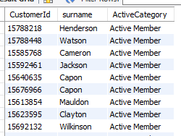

Q26. Can you observe any data disrupency in the Customer’s data? As a hint it’s present in the IsActiveMember and Exited columns. One more point to consider is that the data in the Exited Column is absolutely correct and accurate.

select
*
from bank_churn
where Exited = 1 and IsActiveMember = 1;

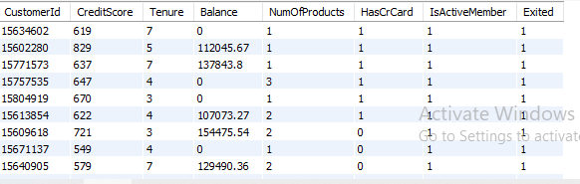

Subjective Questions

Q1. Customer Behavior Analysis: What patterns can be observed in the spending habits of long-term customers compared to new customers, and what might these patterns suggest about customer loyalty?

Insights: We can observe that the customer with 5 years of tenure have the highest average salary (102K) and relatively a higher customer count and lower account balance. We can say that the customers with 5 years of tenure spend a lot.

Financial stability and tenure: We can also observe notable increase in customer count in 4th tenure but after 4th tenure there is a constant decrease in the customers count. The banks should understand the reasons for declining customer count and should up with various strategies and programs for customer retention.

Targeted Engagement: The higher spending capacity of customers with 3–5 years of tenure suggests they may be a valuable segment for targeted engagement strategies. The bank could focus on retaining this group and addressing reasons why customers tend to exit or reduce engagement after 5 years.
Conclusion:
The analysis highlights the importance of considering tenure when examining customer behavior and loyalty. While longer-tenured customers may demonstrate higher earning potential, customer retention efforts should not overlook the needs of newer customers. By identifying and addressing the unique needs of each tenure group, banks can optimize customer loyalty and retention strategies for long-term success.

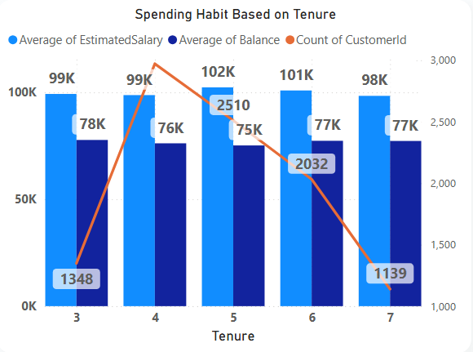

Q2. Product Affinity Study: Which bank products or services are most commonly used together, and how might this influence cross-selling strategies?

Insights:

Commonly Used Products: We can see that the majority of customers (over 50%) use 1 or 2 products, indicating a preference for simplicity or a lack of awareness of additional offerings. Very few customers have moved for 3 or 4 products, suggesting potential interest in more comprehensive banking solutions.

Cross-Selling Potential: Customers using 1 product may benefit from targeted promotions or educational campaigns highlighting complementary services, such as credit cards or savings accounts. We can see a drop in the utilization or products 3 and 4 indicating the challenges in promoting the adoption of additional services.

Active Customer Engagement: The column chart illustrates the distribution of active customers across different product tiers. It is very much essential to focus cross-selling efforts on engaging active customers, as they're more likely to respond positively to offers and recommendations.
Optimizing Cross-Selling Strategies: By leveraging insights from product affinity studies, banks can tailor cross-selling strategies to meet the specific needs and preferences of different customer segments. Targeted marketing campaigns, personalized recommendations, and bundled product offerings can effectively promote the adoption of additional services.

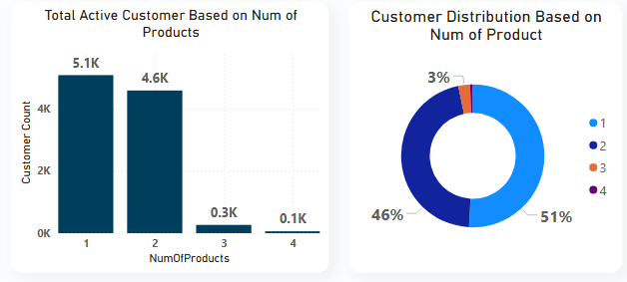

CONCLUSION:
Understanding product affinity and customer engagement levels is critical for developing effective cross-selling strategies. By identifying commonly used products and leveraging customer insights, banks can maximize revenue opportunities as well as enhance customer satisfaction and strengthen long-term relationships.

Q3. Geographic Market Trends: How do economic indicators in different geographic regions correlate with the number of active accounts and customer churn rates?

Insights:

Customer distribution across regions: We can observe that France has the highest numbers of customers followed by Germany and Spain with varying market sizes indicating the potential opportunities for expanding business activities.

Churn Rates: Here we can see that the churn rate or the percentage of customers who have exited from the bank varies from region to region. Germany has the higher churn rate with 32.44% followed by Spain (16.67%) and France (16.15%).

Despite the churn rates, over 80% of the customers remain retained in various regions particularly, in France and Spain. Thus, we can analyse the factors contributing to retention rate which can used in the regions where there is higher churn rate and retention strategies are needed therefore.

Economic Indicators: Economic indicators such as GDP growth, unemployment rates, standard of living and household income levels may influence customer behavior and banking outcomes.

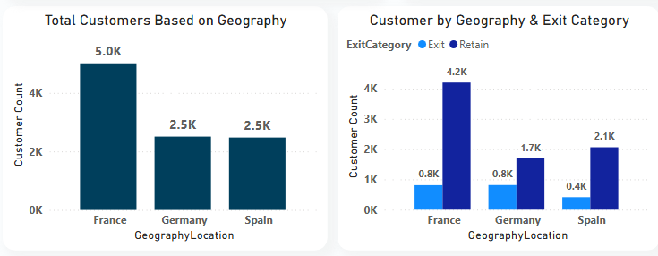

Conclusion: Understanding the reasons behind the churn rate in various regions will help the bank to improve the level of customer satisfaction and will also help in building various retention strategies.

Q4. Risk Management Assessment: Based on customer profiles, which demographic segments appear to pose the highest financial risk to the bank, and why?

The highest concentration of customers falls within the 0-20 age bucket, with around 6K customers.
Most of these customers are active members (in blue), while a smaller but significant portion is inactive.

Inactive members: We can see that in the age bucket of 0-20 and 20-40 the inactive member count is highest suggesting that the younger customers might be at risk of becoming inactive.

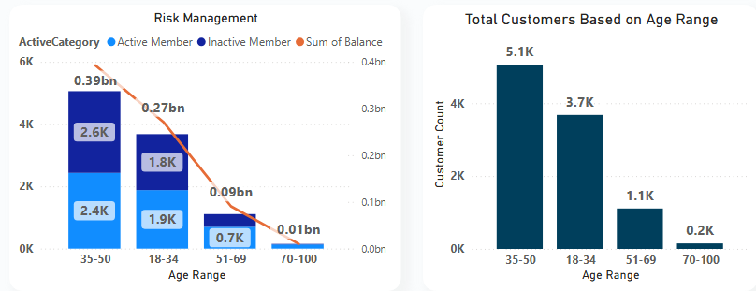

Balance Distribution by age: We can also see that the balance is at peak in age 0 -20 and then gradually decreased from 20-40 and much lower when it comes to older age customers.

Risk Concentration by Age: We can see the younger customer (0-20) and (20-40) have the majority of banks total balance. Therefore, managing risk in these groups is very much important as they didn’t only posses the higher balance but the percentage of inactive members is also high.

While in the oldest age bucket the number of customers is low and the balance is also very low, indicating low risk in financial terms.
Strategy: Since the younger age customers carry the higher balance the efforts to increase engagement and customer retention among inactive younger customer can be beneficial.

With the oldest age bucket the engagement strategies may not impact the bank’s overall balance but it can create the diverse growth opportunity.

Conclusion: Overall, the chart emphasizes the importance of focusing on young customers in risk management as well as retention strategies, given their high balance and potential to become inactive.

Q5. Customer Tenure Value Forecast: How would you use the available data to model and predict the lifetime (tenure) value in the bank of different customer segments?

Insights:
Financial stability and tenure: We can also observe notable increase in customer count in 4th tenure but after 4th tenure there is a constant decrease in the customers count. The banks should understand the reasons for declining customer count and should up with various strategies and programmes for customer retention.

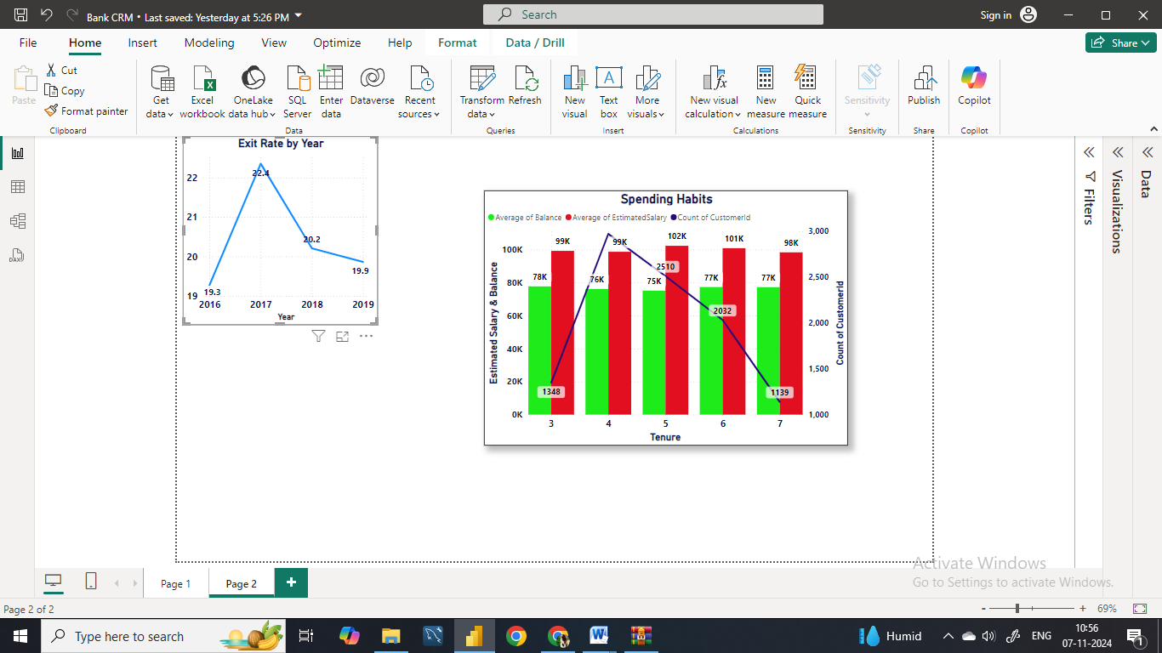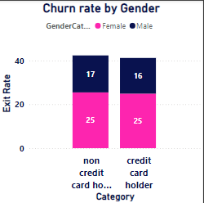

Targeted Engagement: The higher spending capacity of customers with 3–5 years of tenure suggests they may be a valuable segment for targeted engagement strategies. The bank could focus on retaining this group and addressing reasons why customers tend to exit or reduce engagement after 5 years.

Customer distribution by credit score : We can see that the Fair credit scores categories have the highest number of customers (3.3k) . This indicates that most of the customers of the bank have Good or Fair Credit score.

Average balance by credit score: We can see that the Very Good and excellent credit score have the higher average balance.

The average balance does not decreases with the decrease in credit score categories indicating that the customers with lower credit scores can hold sufficient balance.

Therefore it shows that the credit score is not the strong indicator of the balance size. One should consider the factors beyond the credit scores while analyzing the risk.

Strategy: For Good and Fair categories bank should focus on enhancing the relationship and encourage the customer for more product usage.

Conclusion: In summary, we have seen that the large number of customers have good or fair credit scores, therefore targeted approach to engaging those in lower credit categories with high balances might help the bank manage risks more effectively and encourage overall customer retention.
Q6. Marketing Campaign Effectiveness: How could you assess the impact of marketing campaigns on customer retention and acquisition within the dataset? What extra information would you need to solve this?

Campaign Effectiveness over Time: We observed variations in exit rates over the years 2016 to 2019. In 2017, the exit rate was highest at 22.4%, followed by 2018 at 20.2%. However, the exit rate decreased slightly in 2019 to 19.9%, suggesting potential fluctuations in customer churn rates in response to marketing campaigns over time.
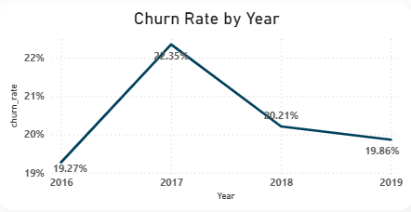
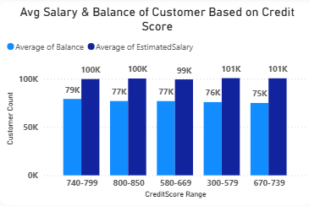

Customer with higher credit score tend to have higher account balance and estimated salary. The customers with Very Good credit score have approximately 79 k balance and 100K estimated salary and the customers with excellent credit score have around 77k average balance and around 100k estimated salary.

Conclusion: By leveraging the insights gained from the analysis of credit scores categories, financial profiles over the time period and the churn rate, the banks can take informative decision so that they can optimize their engagement and marketing strategies and can build long term customer loyalty and relationship.

Q7. Customer Exit Reasons Exploration: Can you identify common characteristics or trends among customers who have exited that could explain their reasons for leaving?

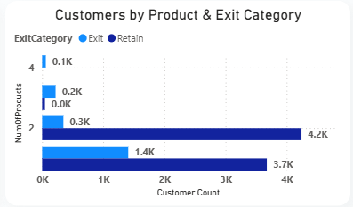

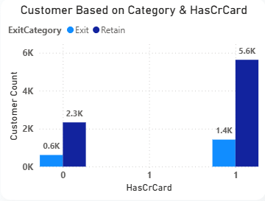

After analyzing above 2 charts, we can say the main reasons for customer exit are as follows:

Credit Card Ownership: The chart reveals that a significantly higher number of customers with credit cards exited the bank (around 1,424) compared to those without credit cards (around 613).

Fewer Products Purchased: The highest number of exits occurred among customers who purchased a single product (around 1,409). As the number of products purchased increases, the exit rate decreases. Customers who bought four products have the lowest exit rate, with only about 60 exits. This indicates that customers who engage more with the bank by purchasing multiple products are less likely to churn.

Q8. Are 'Tenure', 'NumOfProducts', 'IsActiveMember', and 'EstimatedSalary' important for predicting if a customer will leave the bank?

Let’s consider tenure, number of products and estimated salary to predict whether a customer will leave the bank by using exit category for churn and active customer data.
The analysis is based on below 3 charts that visualize these factors for both customers who exited and those who remained.

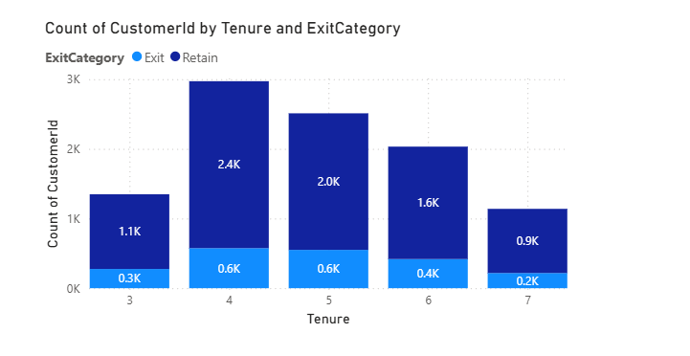
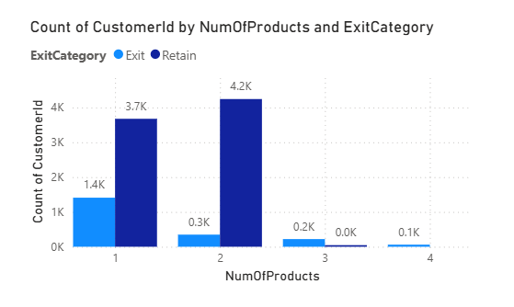

Tenure:
The number of years that the customer has been a client of the bank can be a significant factor. Normally, older clients are more loyal and less likely to leave a bank1.
While comparing the relationship with tenure of the customers and the exit rate of the customers we can find a key relationship that the customers who have a tenure of greater than or equal to four years are more likely to retain than others.

Number of Products:
The number of products a customer has with the bank could potentially influence their decision to stay or leave. There is no consistent pattern between the number of products a customer holds and their likelihood of exiting.
Customers with multiple products might have a higher level of engagement with the bank, which could reduce the likelihood of churn.

Estimated Salary:
While one might assume that a customer’s estimated salary could influence their likelihood to churn, it has been found that estimated salary showed little to no correlation with churn.
This could be due to a variety of factors, such as the customer’s satisfaction with the bank’s services, which might not necessarily be tied to their income3.

These are general trends and may not apply to every customer. A comprehensive analysis should be conducted using appropriate statistical and machine learning techniques to determine the significance of these factors in predicting customer churn. It’s also important to note that the importance of these factors can vary depending on the specific context and customer base of the bank.

Q9. Utilize SQL queries to segment customers based on demographics and account details.

Query:

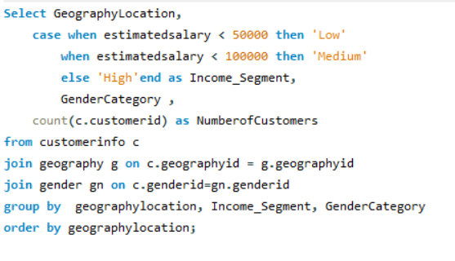
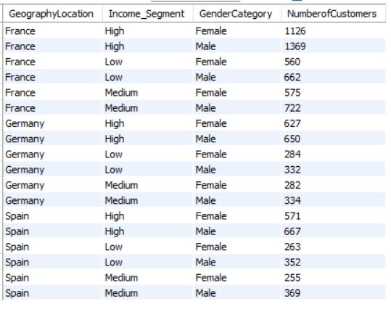

Q10. How can we create a conditional formatting setup to visually highlight customers at risk of churn and to evaluate the impact of credit card rewards on customer retention?

Identifying Customers at Risk of Churn:- You can identify customers who are likely to leave the bank by setting specific criteria, such as low account balances, inactive memberships, or low engagement levels. The following query selects customers who have already exited (Exited = 1) and either have an account balance below 1000 or are inactive members. This helps in recognizing patterns that contribute to customer churn.

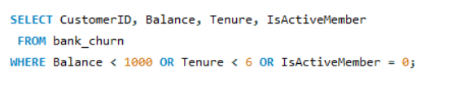

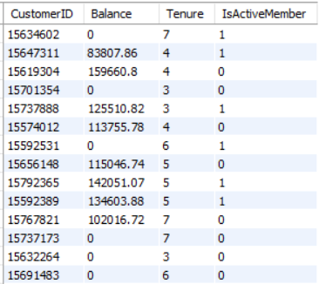

Evaluating the Impact of Credit Card Rewards on Customer Retention:- To measure how credit card rewards affect customer retention, you can compare churn rates between those who have a credit card and those who don’t. This query calculates the average churn rate (Exited) for both groups based on the HasCrCard column. Analyzing this data will help determine whether having a credit card influences a customer's likelihood of staying with the bank.

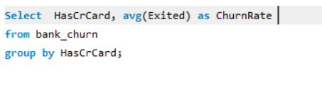
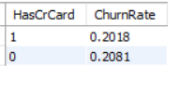

Q11. What is the current churn rate per year and overall as well in the bank? Can you suggest some insights to the bank about which kind of customers are more likely to churn and what different strategies can be used to decrease the churn rate?

Churn Rate Overview:

The bank’s overall churn rate is 20.37%, with year-on-year fluctuations:
2016: 19.27%
2017: 22.35% (highest)
2018: 20.21%
2019: 19.86% (lowest)
Based upon the analysis we did in the before questions.

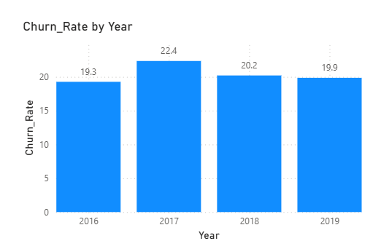

Customer Segments Prone to Churn:

Single Product Users: Customers using only one product may not see enough value in the bank's offerings, particularly when competitors provide broader or more integrated services.

Credit Card Holders: Potential factors for credit card holders churning include:

Insufficient credit limits.
Lack of appealing rewards programs.
High fees associated with the card.

Tenure of 4-5 Years: These customers might be coming off promotional offers or discounts, making them susceptible to competitors offering more attractive rates or features.

High Salary Customers: High earners may have more financial options and are more likely to switch banks for slightly better benefits or interest rates elsewhere.

Recommendations to Reduce Churn:

Targeted Product Bundles:
Develop tailored product bundles to address the specific needs of customers who use only one product. Highlight the added value and potential cost savings of using multiple services.

Enhanced Credit Card Rewards:

Improve the credit card offering by:

Increasing credit limits based on customer behavior and creditworthiness.
Aligning rewards programs with customer preferences (e.g., travel, cashback for certain categories).
Reducing or eliminating annual fees, especially for high-value customers.

Retention Offers for Existing Customers:
For customers nearing the end of their introductory offers, proactively offer personalized retention deals.
Like extending the promotional rates and Providing discounts on other products or services.

Customer Satisfaction Surveys:
Regularly survey customers to gather insights into why they leave. Use this feedback to fine-tune retention strategies and address customer pain points.

Relationship Management for High-Value Customers:
Assign dedicated relationship managers to high-value customers, offering them personalized services and exclusive benefits to strengthen loyalty and meet their individual needs.

By focusing on these strategies, the bank can reduce churn, retain high-value customers, and increase overall customer satisfaction.

Q12. Create a dashboard incorporating all the KPIs and visualization-related metrics. Use a slicer in order to assist in selection in the dashboard.

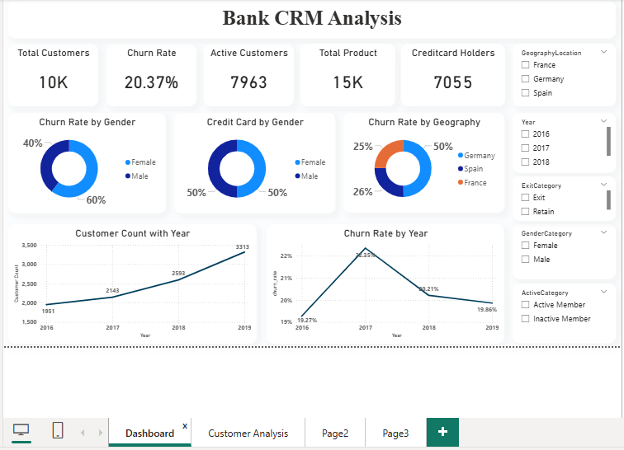

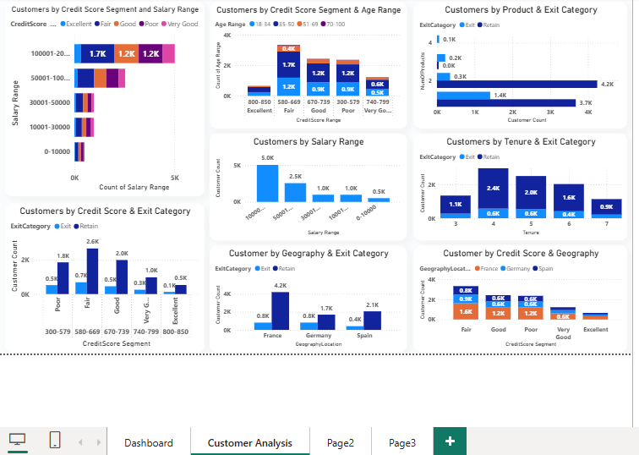
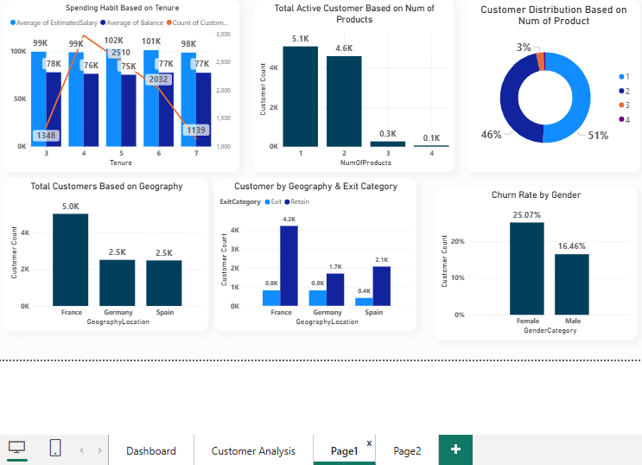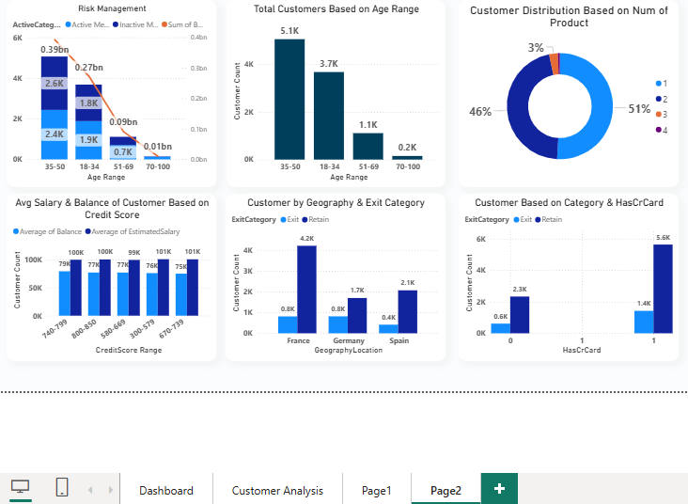

Q13 . How would you approach this problem, if the objective and subjective questions weren't given?

Structured Approach
Understanding the Context:
Gain a clear understanding of the analysis objectives and underlying business needs.
Consult stakeholders or review project documentation to uncover implicit expectations.
Exploratory Data Analysis (EDA):
Examine the dataset’s structure, distributions, and relationships to identify key patterns.
Detect any outliers, anomalies, or trends that may influence the analysis.
Identifying Insights:
Generate initial insights based on observed trends and relationships within the data.
Consider both quantitative metrics and qualitative factors relevant to the domain.
Formulating Hypotheses:
Develop hypotheses based on early findings to guide further investigation.
Use these hypotheses to refine analytical focus and explore potential causations.
Iterative Analysis:
Apply various analytical techniques such as statistical analysis, machine learning, or data modeling.
Utilize tools like Excel, Power BI, and SQL to experiment with different approaches and refine insights.
Data Visualization & Communication:
Leverage charts, graphs, and dashboards to represent insights effectively.
Use visual storytelling to highlight key patterns and make findings more accessible to stakeholders.

Synthesizing Findings:
Consolidate insights into a cohesive narrative, identifying overarching themes and trends.

Validation & Stakeholder Feedback:
Verify results through peer reviews, expert assessments, or external benchmarks.
Gather feedback from stakeholders to ensure the analysis aligns with business goals and provides actionable recommendations.

This structured approach enhances the effectiveness of data analysis, making insights more meaningful and impactful.

Q 14. In the “Bank_Churn” table how can you modify the name of the “HasCrCard” column to “Has_creditcard”?

To rename the column "HasCrCard" to "Has_creditcard" in the "Bank_Churn" table, you would generally use the ALTER TABLE statement in SQL. Here’s how you can achieve this:

